***Report on the Creation of Viola Aotearoa: The Next Generation***

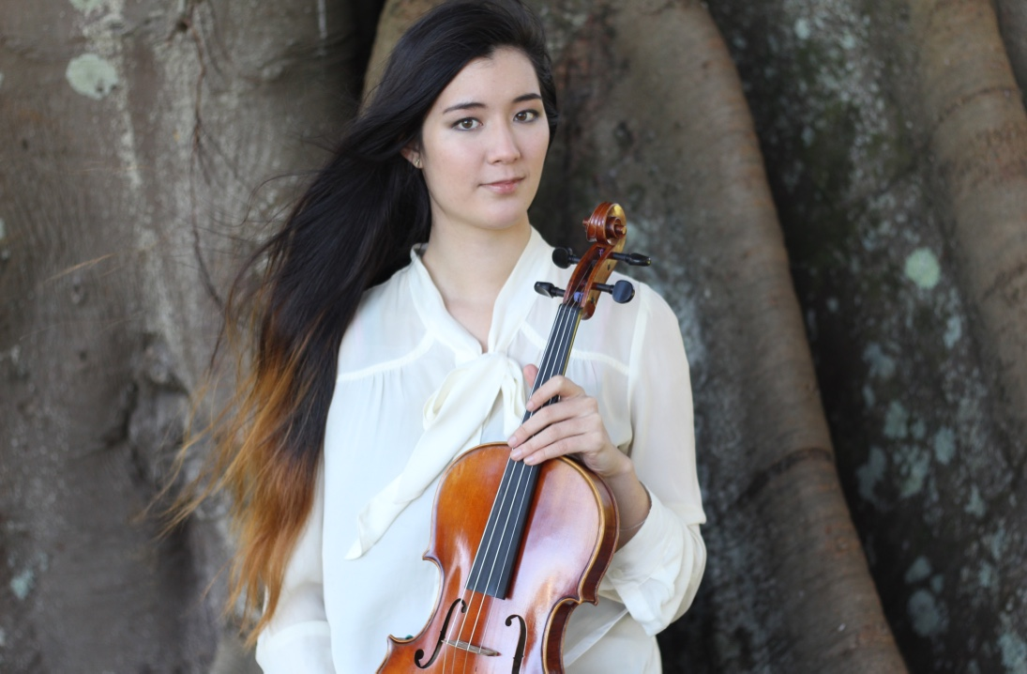The Judith Clark Memorial Fellowship has allowed me to do some really amazing projects. This year, the funding I applied for went towards making a recording of some core New Zealand solo viola repertoire, and will contribute to putting on several recitals of New Zealand viola music in my current city of Houston, Texas. The recital component of the project was originally intended to be completed and recorded in State College, Pennsylvania, but due to the timeframe of when I found out my application was successful and the school-year at Penn State, most of my prospective audience had left the area by the time I was able to contemplate putting on the recital. Also, in Houston (the fourth-largest city in the USA), I will be able to reach a much larger and more diverse audience with this music.

It was an absolutely incredible experience recording in studio. The process was so exciting and educational. To summarise, each session would begin with a setup of multiple microphones in various locations in the soundproof room. Then we would start by recording a full run of the piece we were working on that day, and then we would record larger sections (one to two pages) of the material, and if absolutely necessary we would isolate smaller sections if there was a particular effect that we really wanted to have multiple takes of to ensure the best possible result. When I say “we”, I refer to myself and my recorder/producer, Jonathan Dexter. It was such a pleasure to work with him as he is also a very accomplished cellist whose musical opinion I highly respect.

I learned so much about not only recording through this process, but also, my own playing and myself. I found creating this studio recording a really fun and rewarding process, and it was very interesting to hop out of the studio occasionally to hear how things were going. I would immediately notice how things sounded, and also because of the high quality of the sound on the recording and how true to reality it was, it was easier than ever to spot those things that I wanted to do differently and go back to the studio to make the changes right away. In some ways hearing oneself (as objectively as possible) is one’s best teacher. I also developed a deep appreciation for the pieces I recorded, Martin Lodge’s “Pacific Rock”, the Anthony Watson solo viola sonata, and Jack Body’s “Aeolian Harp”.

The other extremely valuable lesson I learned was in regard to personal well being as an artist. Although I am of course extremely grateful for being awarded the funding and in no way do I wish to appear ungrateful – I realised that I probably should have either applied for more funding, or attempted to do less in this project. I had a big problem with having to continue to work my minimum-wage job at a bakery with 5am-1pm shifts 4-5 days a week (unfortunately the best prospects I had in a small town like State College, Pennsylvania, and necessary to cover rent and expenses) whilst trying to pursue this project, because I only applied for enough funding to cover the materials and the recording fees and although I had thought about it, I did not adequately plan for how much time it would require to learn the music to the very high standard necessary to make such permanent recordings, not to mention the many hours in the studio and late nights followed by such early mornings. And so at times, it was rather exhausting – but luckily, well worth it.

While at Rice University’s Shepherd School of Music, I intend to continue this project in the studios at the Digital Media Center at the Fondren Library, which are free for students to reserve. I have taken a part-time job at the DMC and so I will learn about using the cameras and microphones as a part of my job, and therefore be able to record my own work to a very high quality. I hope to get through more of the unaccompanied NZ viola works, as well as doing some of the great NZ works for viola and piano in recitals around Houston.

I haven’t received the final product yet as Mr. Dexter has had a very busy summer schedule and I had told him that quick results were not as important as having the best results. As soon as I receive the recordings I will forward them onto you so that you can have a copy of the work these funds have helped to create! I am so very grateful and honoured to have received the support, both financially and emotionally, from the Judith Clark Memorial Fellowship. It is a very special feeling as an artist far overseas to know that people in your home country are behind you and invested in your development in the most positive way. Support like this only makes me ever more determined and motivated to succeed, for myself and for New Zealand.